Final Project Report — Programming Fundamentals
University Name: FAST (National University of Computer & Emerging Sciences
Karachi Campus)

Department: Department of Computer Science
Course: Programming Fundamentals
Project Title: Rewordling Wordle
Submitted By: Rabisa Ali (25K-0876) Syeda Marium Fatima (25K-0970)
Submitted To: Ms.Kinza Mushtaq
Semester: Fall 2025
Date: November 21, 2025

Abstract
Rewordling wordle is a console-based game developed in C language to implement online wordle game efficiently. A player will be given ten consecutive Wordle puzzles. However, a single failed attempt to guess the word will lead to the termination of program. At the end, the program will calculate the average number of guesses, best guess, and a percentile ranking of pre-hard coded player performance data collected from google. This project applies fundamental programming concepts such as loops, arrays, and functions. This takes Wordle beyond a casual guessing game to something much more intense.
- Introduction
Wordle is an online word puzzle game where a player has six attempts to guess a five-letter word. Feedback is given through colored tiles: green for a correct letter in the right spot, yellow for a correct letter in the wrong spot, and red for a letter not in the word at all. The goal is to guess the hidden word using this feedback within the limited attempts. Although there are numerous Wordle implementations online, most of them offer instant win or loss results without any in-depth analytical insights.
- Objectives
- To find the hidden word using the feedback within the attempts.
- To find out the average number of tries it took the user to judge the word
- To find out the best guess
- To provide a percentile ranking
- To reinforce programming concepts like loops, arrays, and functions.
- To provide a simple, user-friendly interface.

3. System Design
System Overview
Flow of the program:
Start → Load the words into memory → Display instructions → Ask the user to enter the word → Compare the word with the original word and change the font color accordingly → If the user guessed the word correctly within the set number of tries, ask him if he want to continue. If yes then continue, else end the game → End the game by displaying average number of guesses in which the user was able to guess the word correctly, best guess, and his percentile ranking → Exit.
Algorithm
1. Start the program
2. Load the words into memory
3. Display instructions
4. Ask the user to enter the word
5. Compare the word with the original word and change the font color accordingly
6. If the user guessed the word correctly within the set number of tries, ask him if he want to continue. If yes then continue, else end the game.
7. End the game by displaying average number of guesses in which the user was able to guess the word correctly, best guess, and his percentile ranking.
8. End
Input & Output
Input: Guess of the user.
Output: Display instructions, feedback on each word, best guess, average number of tries and the percentile ranking.

4. Implementation
Language: C
Compiler/IDE: Code::Blocks / Dev C++ / GCC
Key Features
- Sequential gameplay of up to 10 word puzzles in a single session
- Immediate session termination upon first failed attempt
- Per-letter feedback system highlighting correct, misplaced, and incorrect letters
- Tracking and averaging of total guesses across solved puzzles
- Hardcoded percentile evaluation based on statistical benchmarks
Code Snippet
int processGuess(char *answer, char *guess) {
int correct = 0;
for (int i = 0; i < 5; i++) {
if (guess[i] == answer[i]) {
printf("\033[92m%c\033[0m", guess[i]);
correct++;
} else {
int found = 0;
for (int j = 0; j < 5; j++) {
if (guess[i] == answer[j] && i != j) {
found = 1;
break;
}
}
if (found)
printf("\033[93m%c\033[0m", guess[i]);
else
printf("\033[91m%c\033[0m", guess[i]);
}
}
printf("\n");
return correct;
}

int game(char* answer, char* guess) {
int guesses = 0;
while (guesses < 6) {
printf("\033[94mEnter a 5-letter word: \033[0m");
scanf("%5s", guess);
guesses++;
if (processGuess(answer, guess) == 5) {
return guesses;
}
}
return 7;
}

Sample Output:
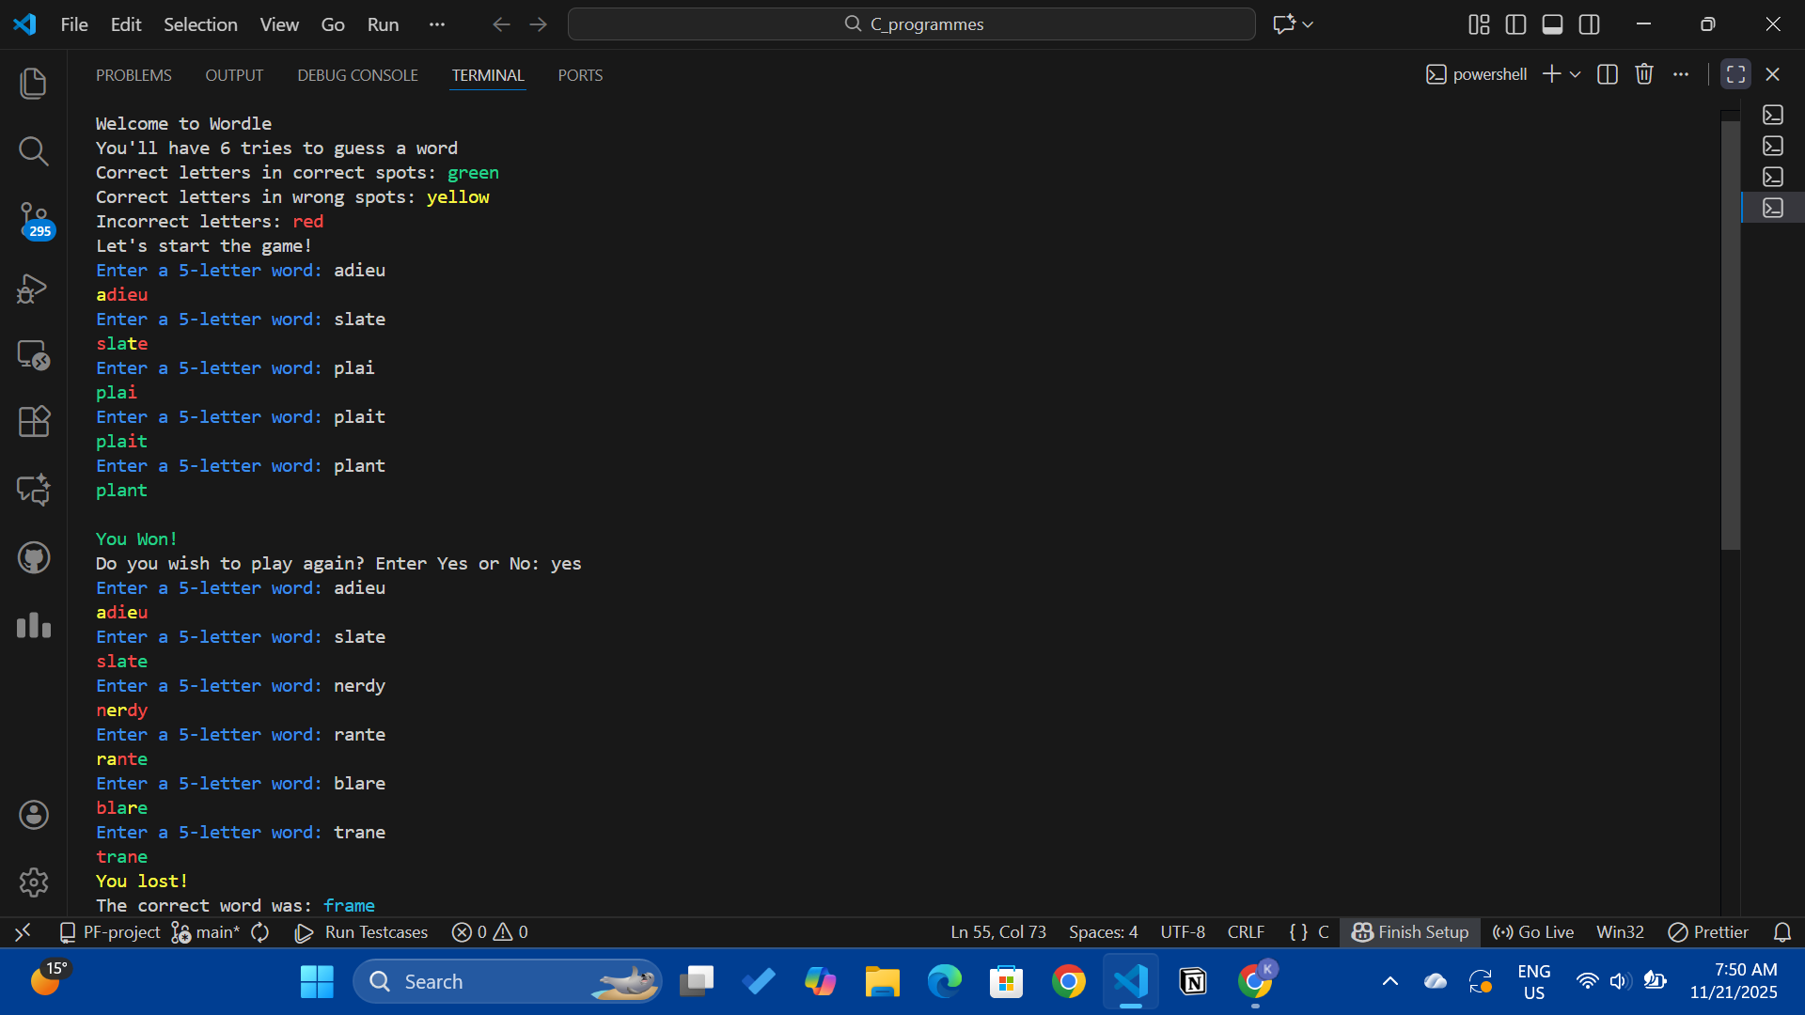

5. Testing and Results
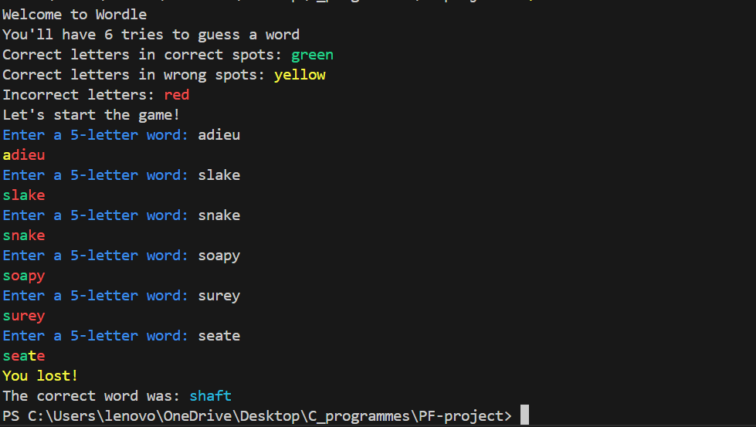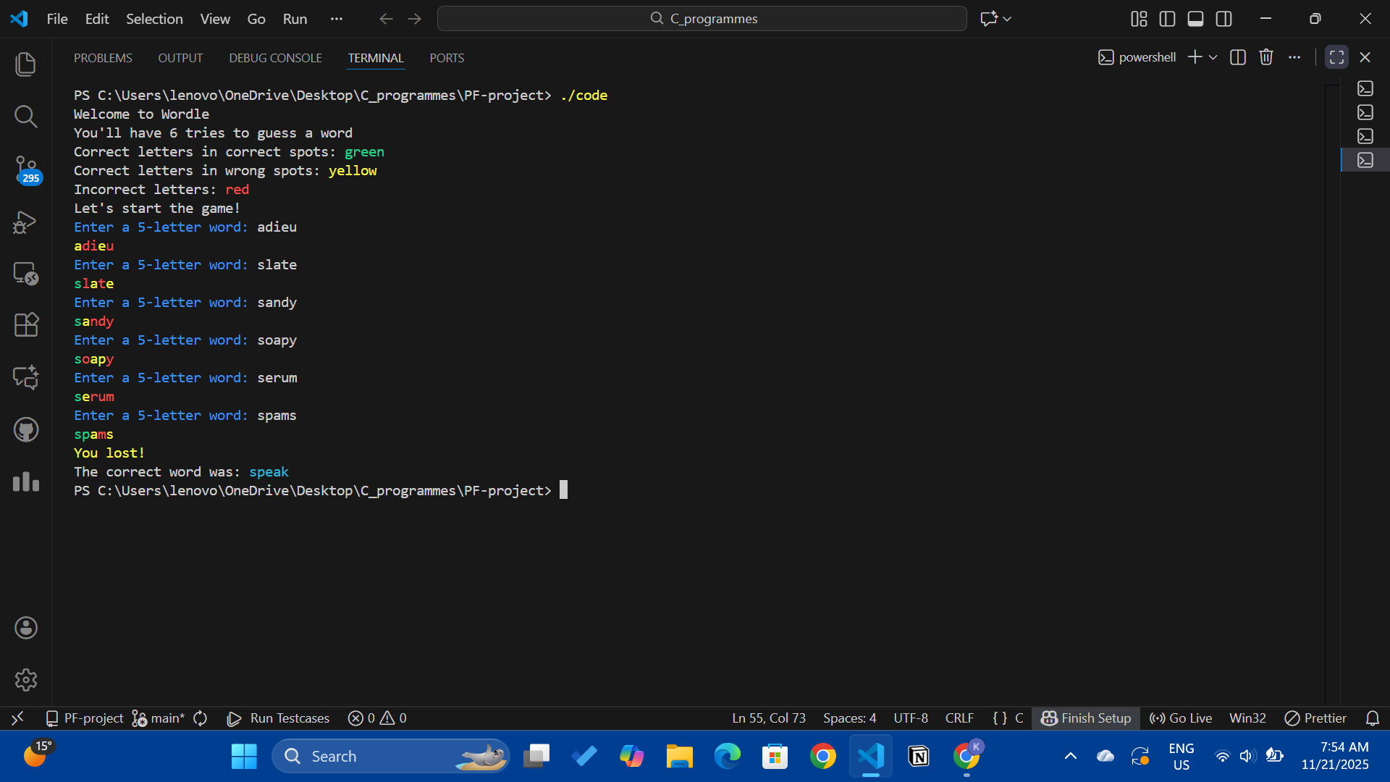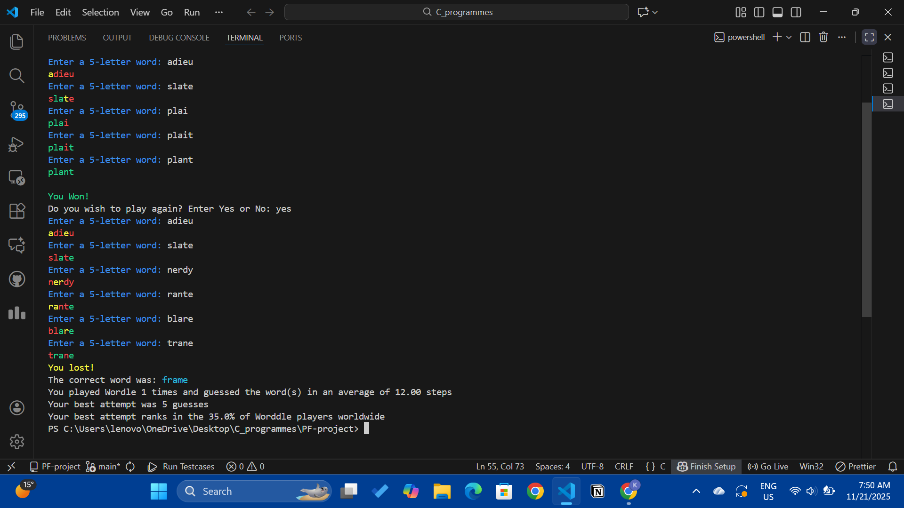
The program performed successfully for all test cases. It handled both correct and incorrect guesses efficiently, produced accurate best guess and percentile. Execution speed was near-instant, and the program required minimal system resources.

6. Conclusion, Limitations &amp; References
Conclusion
The Rewordling Wordle successfully demonstrates the application of basic programming principles. It takes Wordle beyond a casual guessing game to measurable performance evaluation. The project strengthened understanding of arrays, loops, conditional statements, and functions.
Limitations
- Data of average number of guesses and best guess is lost when the program closes (no file handling yet).
- No graphical interface, purely console-based.
Future Enhancements
- Add file handling to store records permanently.
- Implement a graphical or web interface.
References
- Let Us C by Yashavant P. Kanetkar
- https://www.geeksforgeeks.org/c-programming-language/
- https://www.sportskeeda.com
- https://www.nytimes.com › wordle-bot-year-in-review

